CSIS 330 – Lab 7: Packet Tracer

Connecting to a Wired and Wireless LAN Answer Template

**Part 4:**     **Verify Connections**

**Screenshot #1:**

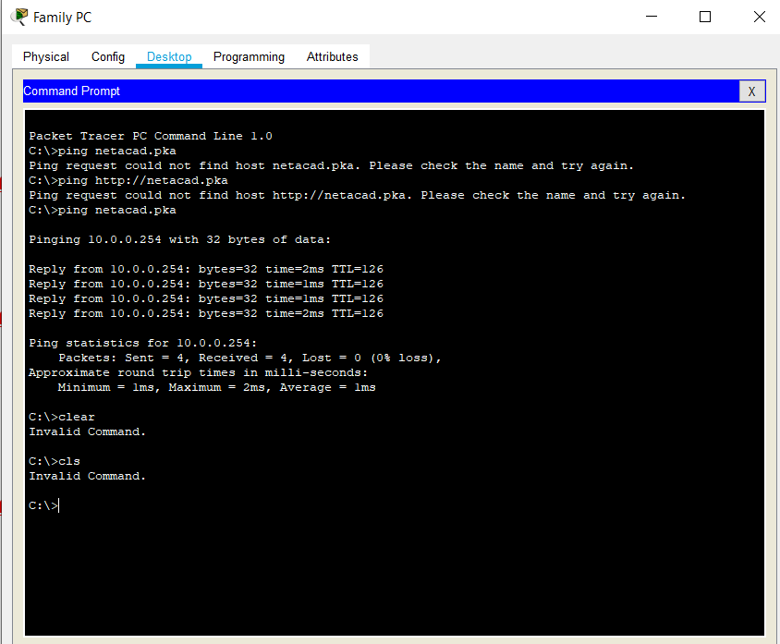

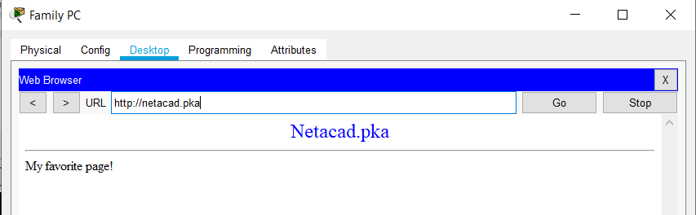

**Screenshot #2:**

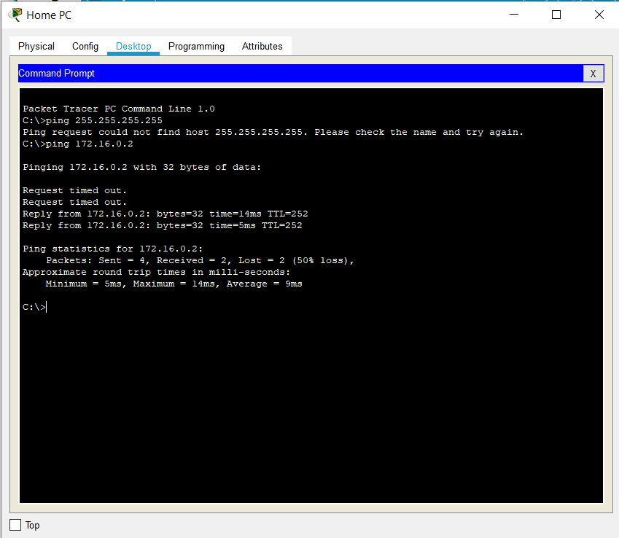

**Screenshot #3:**

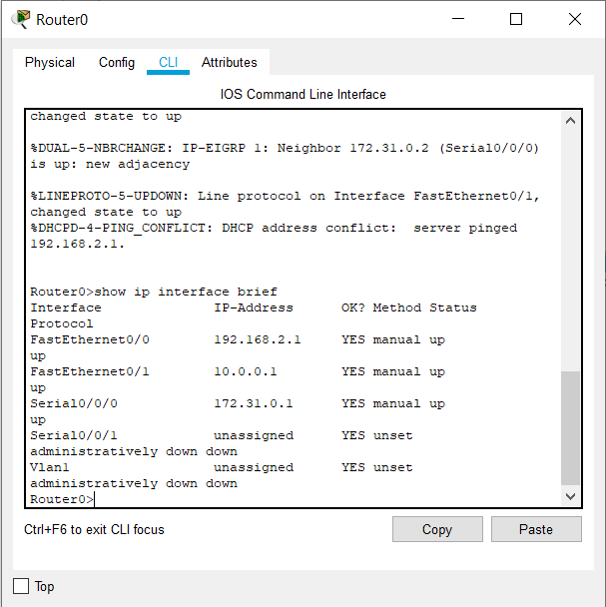

**Part 5:**     **Examine the Physical Topology**

**Step 1:**     **Examine the Cloud.**

c.      How many wires are connected to the switch in the blue rack?

3 wires are connected, one of them being the power cable

**Step 2:**     **Examine the Primary Network.**

1. What is located on the table to the right of the blue rack?

Configuration Terminal

**Step 3:**     **Examine the Secondary Network.**

1. Why are there two orange cables connected to each device?

One cable is for sending data and the other is for receiving data

**Step 4:**     **Examine the Home Network.**

1. Why is there an oval mesh covering the home network?

To represent the range of the wireless network

b.     Why is there no rack to hold the equipment?

Home networks usually do not have racks